Deliverable 3.2 – Technical Specifications

Introduction 3
Scope 3
Relations to WPs 3
Methodology 4
Overall Architecture and Components 5
Architecture overview 5
Architecture components 5
Security Testing/Assessment Engine(SLC) 5
Risk Assessment Guidelines and Recommendation Engine (SLC) 5
Synthetic Data Generation Engine (AVI) 5
Security, Trust, Robustness Assurance Engine (CBRL) 5
Security Runtime Monitoring Engine (DIE) 5
Context Awareness Engine (TID) 6
Coevolution Hub Front End/Dashboard (AEGIS) 6
Coevolution Hub Backend (AEGIS) 6
User and Credential Management (AEGIS) 6
Orchestrator (AEGIS) 6
Service management (AEGIS) 6
Knowledge Base-Pools (AEGIS) 6
Security Assurance AIMBOM Pool (AEGIS/ISI) 6
Assessment Tools Pool (AEGIS/AVI) 6
Trusted Resources Pool (AEGIS) 6
STR Defense Framework (AEGIS/UNICA) 6
Software/Hardware Libraries (UNICA) 6
STR enhancement Tools (UNIPI) 6
Data Defense Tools (UNICA) 6
Gadget Pool (TID) 6
User Types and User Journeys 7
AI Developers/Researcher 7
AI Evaluators (assessors), Engineers 7
End Users 7
Coevolution Core Processes 7
AI Developer/Researcher User Journey 12
AI Evaluator/Engineer User Journey 14
End User Journey 15
Technical Specifications and Interconnections per Component 16
Technical Specifications 16
Interconnections/Interfaces 16
Conclusions 17

Introduction

Scope

Relations to WPs

Methodology
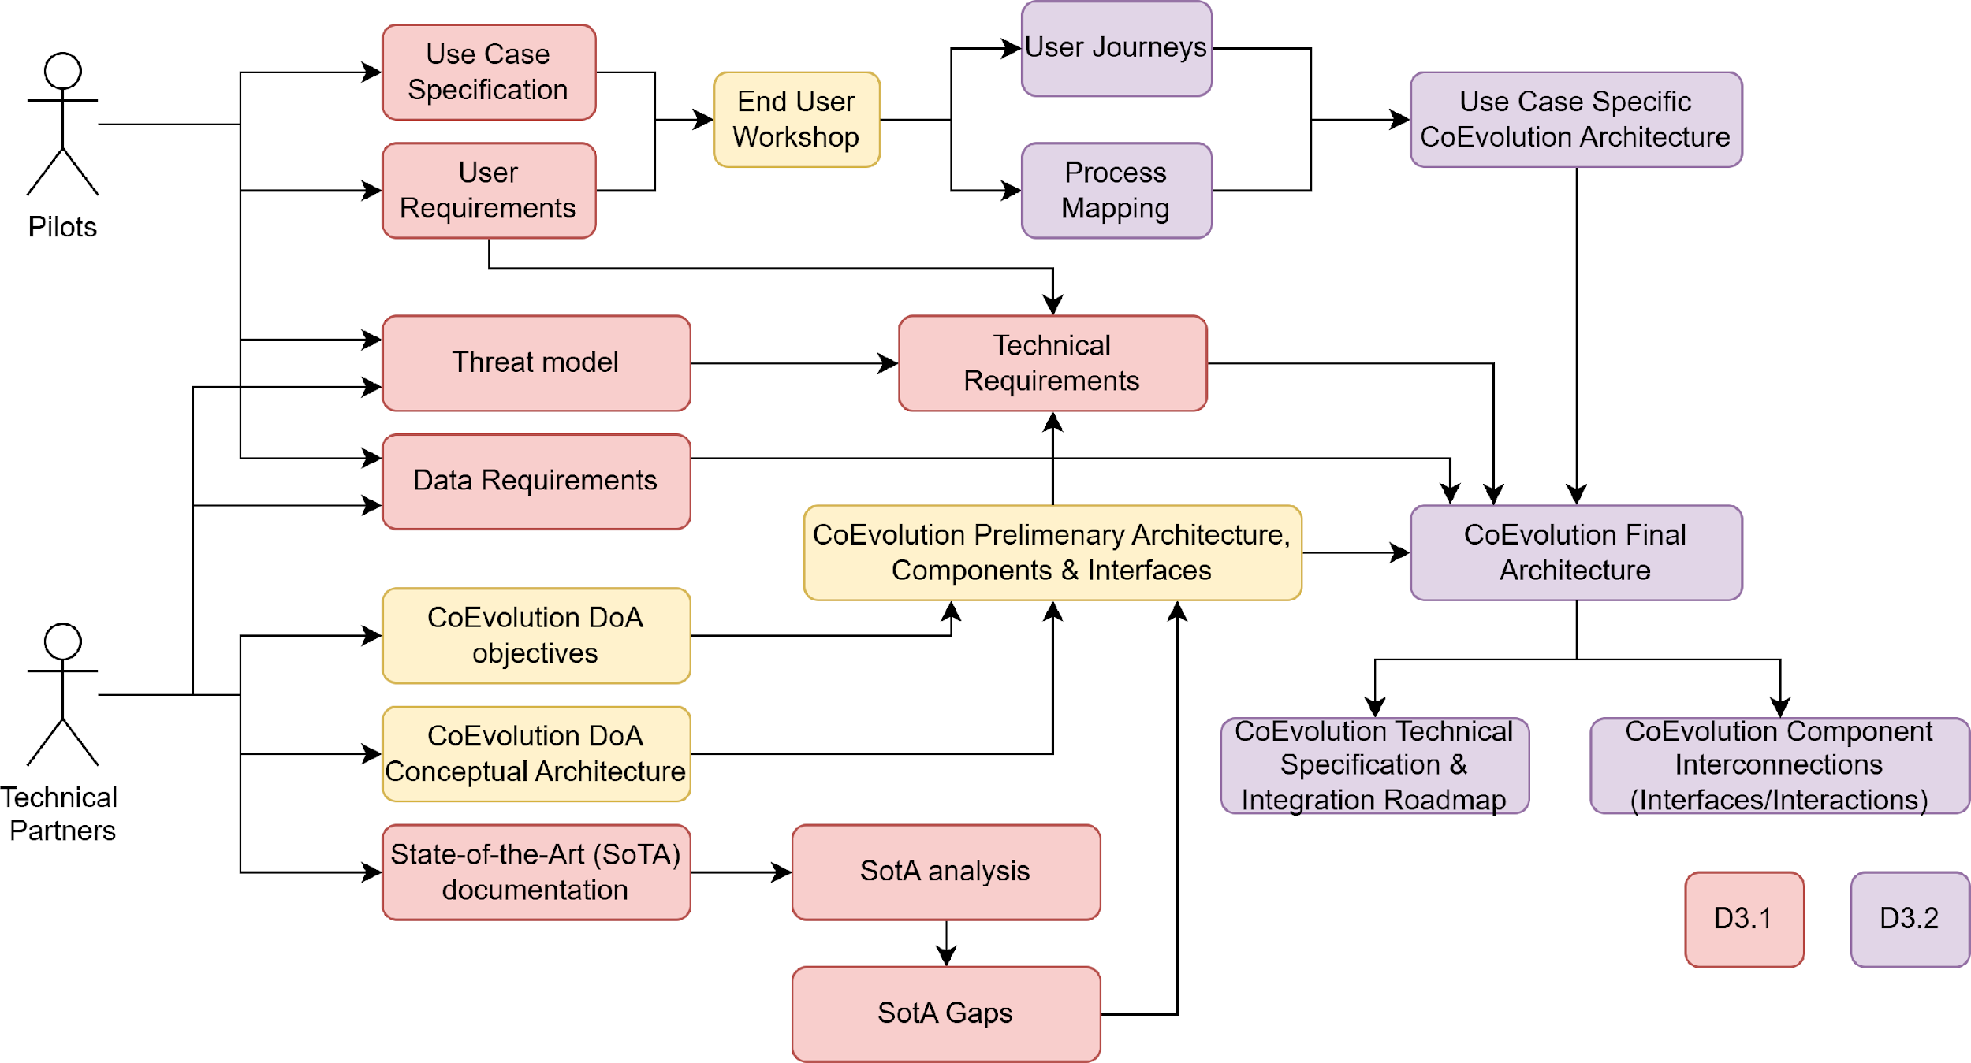

Overall Architecture and Components

Architecture overview
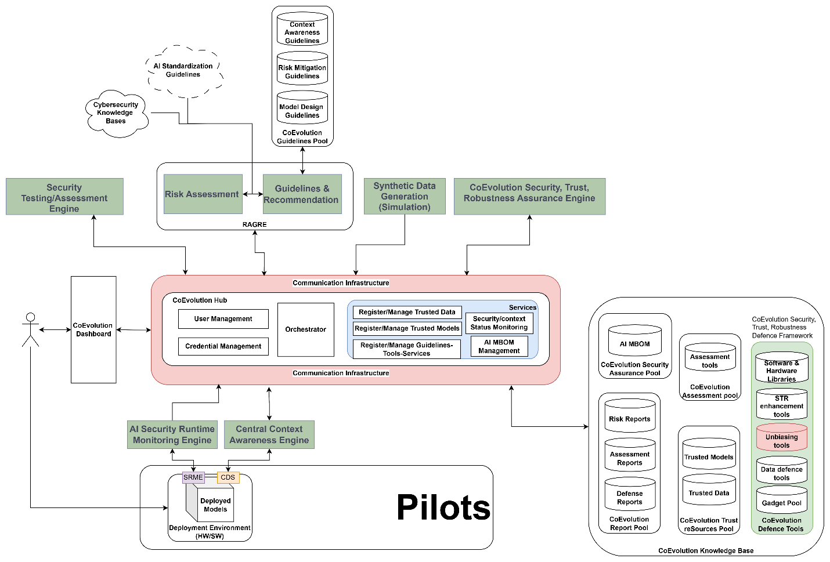

Architecture components

Security Testing/Assessment Engine(SLC)

Risk Assessment Guidelines and Recommendation Engine (SLC)

Synthetic Data Generation Engine (AVI)

Security, Trust, Robustness Assurance Engine (CBRL)

Security Runtime Monitoring Engine (DIE)
AIMBOM Management Mechanism
Security Awareness Mechanism

Context Awareness Engine (TID)

Coevolution Hub Front End/Dashboard (AEGIS)

Coevolution Hub Backend (AEGIS)

User and Credential Management (AEGIS)

Orchestrator (AEGIS)

Service management (AEGIS)

Knowledge Base-Pools (AEGIS)

Security Assurance AIMBOM Pool (AEGIS/ISI)

Assessment Tools Pool (AEGIS/AVI)

Trusted Resources Pool (AEGIS)

STR Defense Framework (AEGIS/UNICA)

Software/Hardware Libraries (UNICA)

STR enhancement Tools (UNIPI)

Data Defense Tools (UNICA)

Gadget Pool (TID)

User Types and User Journeys

AI Developers/Researcher
Users that want to develop AI models that can be verified and approved for use later on and create AIMBOMs.

AI Evaluators (assessors), Engineers
Independent users that want to validate that information inside AIMBOM and the model themselves are correct.

End Users
This type of users corresponds to the end consumers of the CoEvolution solution. End users want to verify and monitor AI models that they have deployed and make sure that the corresponding to models and datasets AIMBOMs and relevant defenses are valid.

User Types
AI Developers/Researcher
AI Evaluator/Engineer
End User

Coevolution Core Processes
Model Deployment and Continuous Security Monitoring
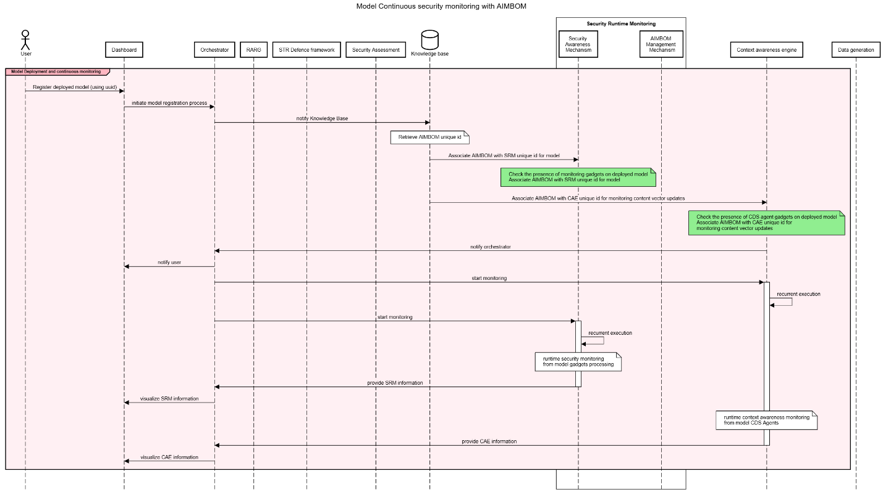
Model/Dataset Risk Assessment and Guidelines recommendation
Model/Dataset Security Assessment
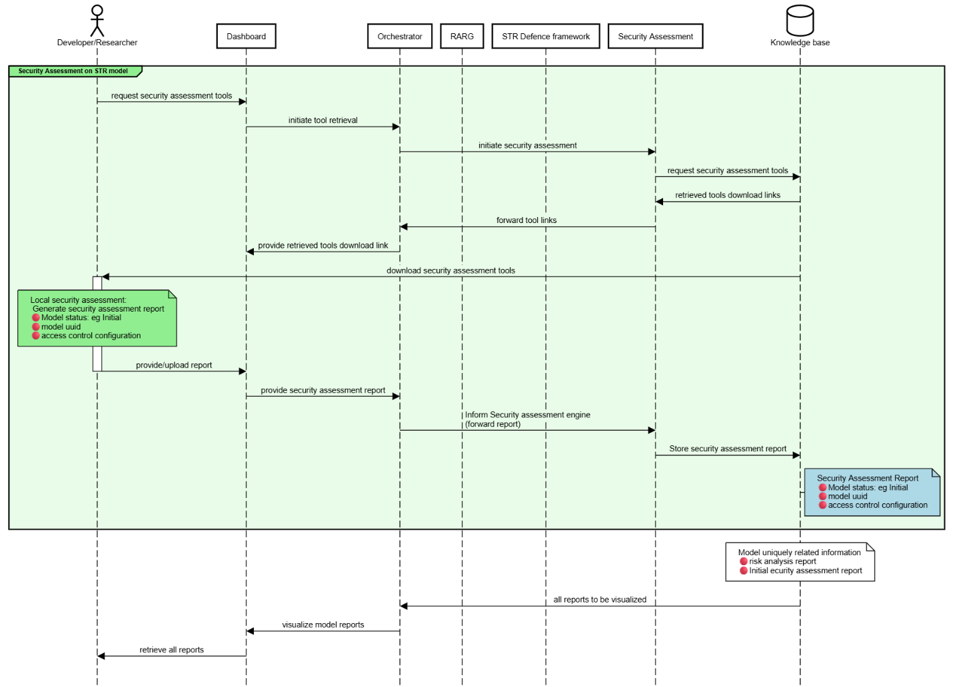
Model STR enhancement (Design/Training focused)
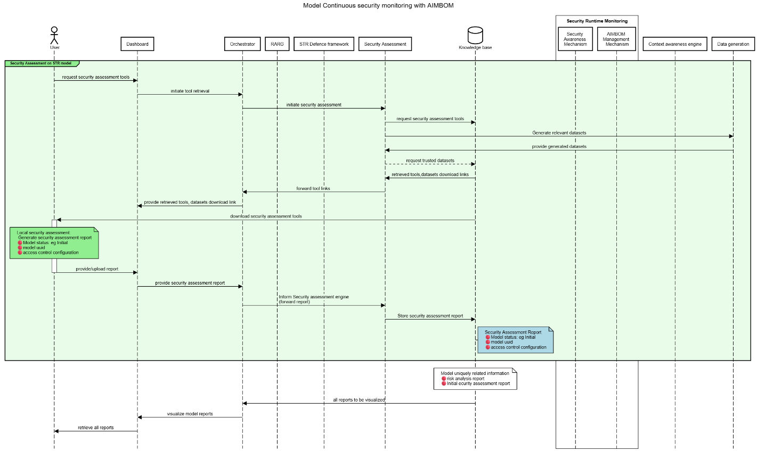
Model STR enhancement (Deployment-Gadgets integration)
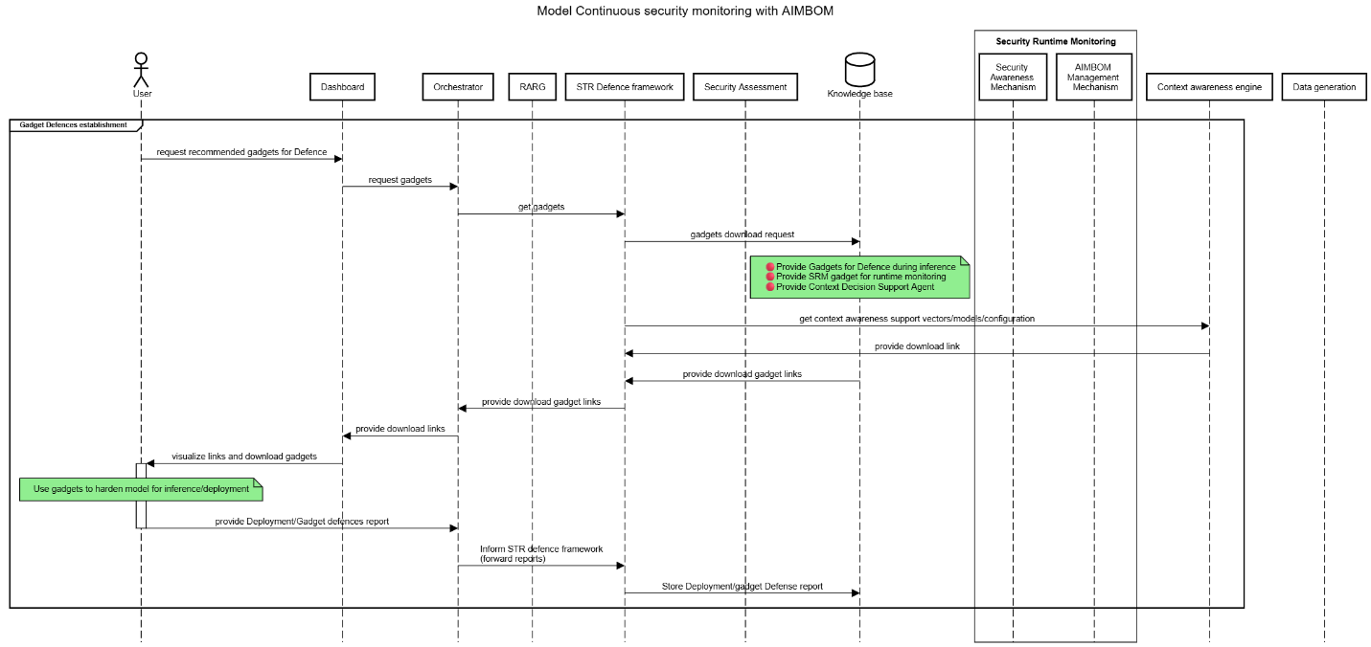
AIMBOM generation
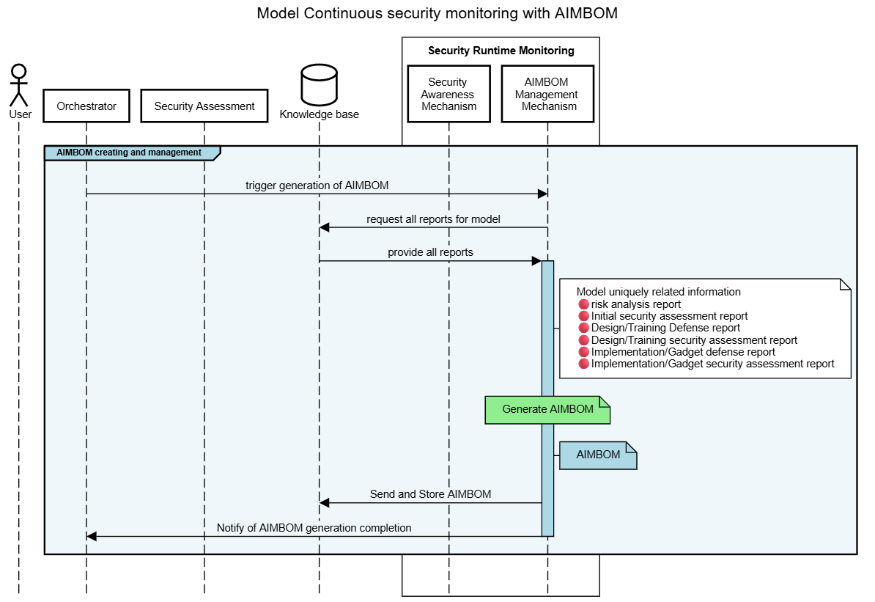
AIMBOM validation
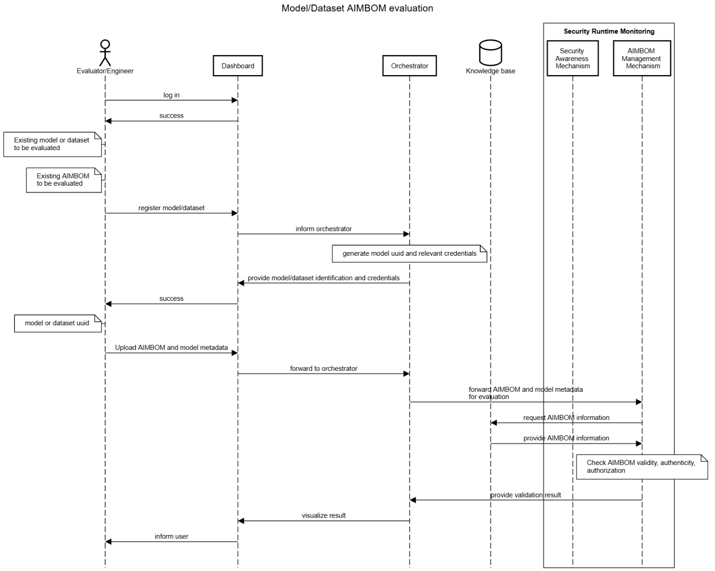
Trusted data/model registration
Trusted data generation

AI Developer/Researcher User Journey
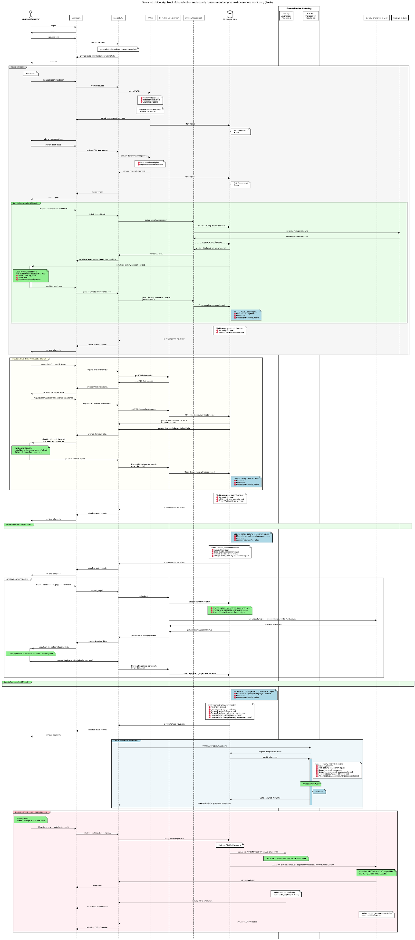

AI Evaluator/Engineer User Journey


End User Journey
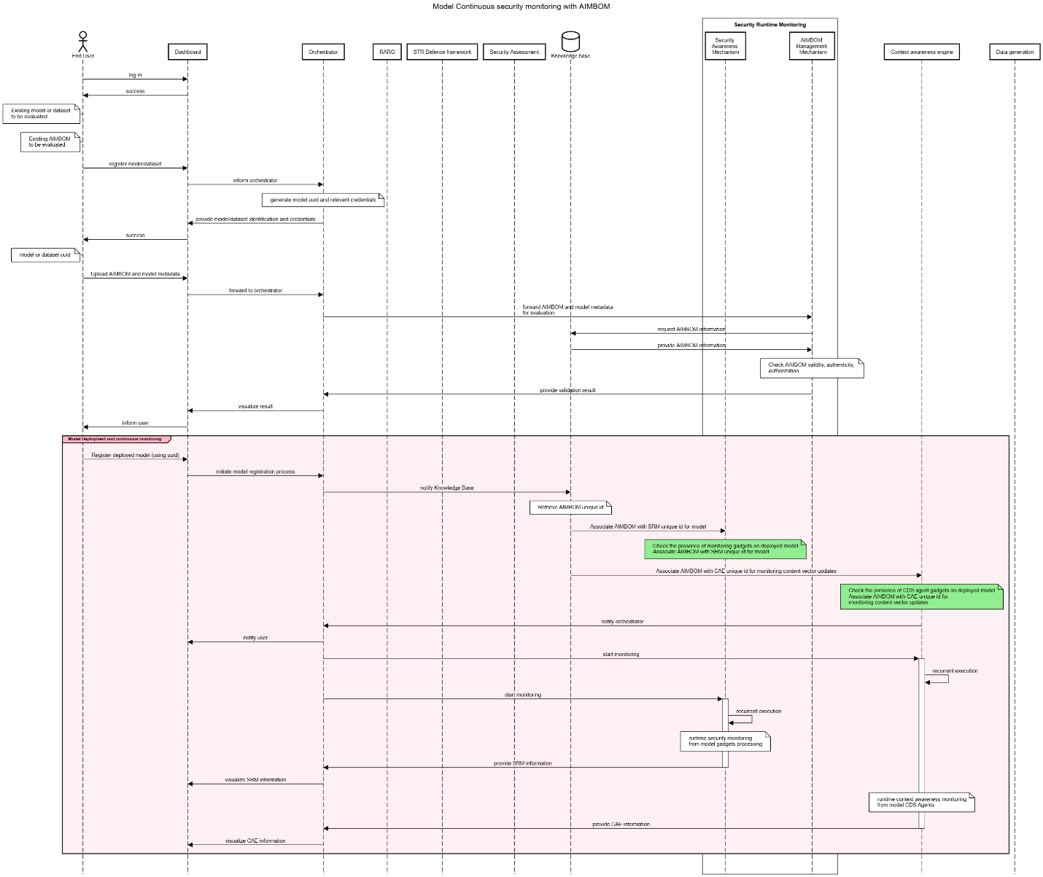

Technical Specifications and Interconnections per Component

Technical Specifications

Interconnections/Interfaces

Conclusions

